Glizzy Detector

Adonis FernandezRunner, Matthew Salagubang, Zarif Shahid, Jaezreel Quiliza, Andrew Stites

Introduction to Engineering || Assignment 3

Professor Praveen Meduri

15 November 2020

Abstract

As the world becomes more technologically savvy, it turns out to be quite a double edged sword. On one hand everyone is being blessed with getting to glimpse the possibility of our future lives. Such exponential advancements in technology definitely has its upsides. But the same upsides turn negative when people use it for criminal activities. One of those criminal activities is drugs. There is without a doubt a massive drug epidemic in the world and it will only get worse in the future if something isn’t done to tackle it. As time goes by, people find new ways to smuggle drugs into different countries. It attracts a lot of attention especially if it is a new drug people have never tried nor know the effects of. That's why the Glizzy Gladiators have teamed up once again to help solve that issue. Our aim is to design a state of the art, never before seen drug detecting robot that will have the ability to detect the use of any illegal substance among people in the facilities. Not only will it be the most effective and powerful drug detecting robot, it will also be a cost effective equipment that many companies and people will be able to afford. This device is not just able to improve society with its temptations, but also with individuals concerned about their fellow loved ones. The strength of this device comes with the behavior mechanisms, analysis capabilities, and the cost effective equipment that is available for everyone and anyone that requires its direct use.

Introduction

The drug epidemic is unfortunately among us with the desire for opiates and other illicit drugs. Trying to drug test everyone is very difficult. Unfortunately, the death rate for drug overdose has risen from about 19,000 in 1999 to 67,300 in 2018[5]. This increase is absolutely terrible; thankfully, it has started to drop from 70,237 in 2017 to 67,300 in 2018 [5]. According to the graphs, men are two times more likely to die from a drug overdose compared to their female counterpart with overall drugs and with specifically opioid drugs. This may coincide with the suicide rate affecting men 3.54 times more than women[6]. The opioid drugs mainly used are prescription opioid drugs, synthetic narcotics, which are usually fentanyl, and heroin[5].

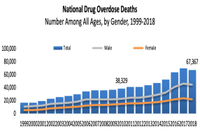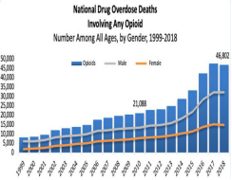

There are a multitude of conduits that bring illicit drugs into the U.S. mainly from the bordering nation of Mexico[4]. Tunnels are a primary factor in the distribution of illicit drugs from Mexico with dozens being discovered along the border owned by the infamous Sinaloa Cartel syndicate[4]. In July of 2015, “El Chapo”, was able to access one of these tunnels to escape from a maximum-security prison. The first tunnel discovered was in 1990 , which was 273 feet in length from Agua Prieta, Mexico to an Arizona drug-filled warehouse[4]. However, the biggest tunnel was discovered in April of 2016, running half a mile from Tijuana, Mexico to a San Diego industrial property according to the San Diego Union-Tribune. In addition to, tons of marijuana and cocaine were funneled through this pathway according to the authorities[4].

In certain cases, catapults are used to fling illicit drugs weighing a total of a little over four pounds over the border according to a Mexican official and Associated Press. It definitely is not as popular as tunnels due to not being the most optimal way of transport over the years. The overall inefficiency and inaccuracy of these machines tie into the reason why they are not heavily used in the distribution of the illegal drug industry[4].

Since the launching of projectiles of ancient fashion was too archaic, the lean towards cannon use became more apparent[4]. According to the authorities of the Mexican state of Sonora, a vehicle was found to be fashioned with an air cannon capable of launching illicit drugs across the border. With the effort to build and deploy these mobile drug launchers, they are not a reasonable choice for drug cartels to employ them and will likely not become a mainstream way of transporting illicit drugs into the U.S.[4].

     The next step would be taking control of the air space and utilizing “UltraLight Aircrafts” to deploy illegal cargo[4]. Evidently, this is not a new choice of transport and was pioneered by the Juarez Cartel kingpin: Amado Carrillo Fuentes who utilized small aircrafts to move packages from one place to another. These smaller aircrafts are primarily used in the shade of night for more disguise due to being slower and able to carry less product[4]. In addition, these smaller aircrafts are harder to detect even though they are closer to the ground and can carry a heavier load of 100 pounds of illicit drugs[4]. According to authorities, this method is the most economical and yields a great fruition due to being low cost and successfully completing tasks at hand.

Other methods involving air control is the remarkable use of drones by cartels and the like. In 2015, six pounds of methamphetamine was carried across the border until the drone crashed right before the crossing[4]. According to Popular Mechanics, the attempts at drone usage have been totaled at over one hundred throughout the years[4]. The feasibility of drone usage when in regards to drug smuggling is not present due to the limitations of amount being transported and the lack of money being generated for drug cartels according to Amy Roderick, U.S. Drug Enforcement Administration (DEA} spokesperson.

With so many illicit drugs being hauled into the states, the need for drug testing is crucial for businesses and other facilities. According to the U.S. Department of Justice, $140 billion is lost in the span of one year due to employees shirking on responsibilities under the influence of narcotics. Employers desire to follow the law and have a clean, safe, and healthy work environment. Employers mandate drug testing to identify and help employees that may need rehabilitation or any other aid to combat the addiction. More importantly, employers want to protect their patrons from narcotic induced employees that may cause an incident that could possibly be harmful to everyone. Over half, according to the U.S. Department of Justice, of workplace incidents are due to the influence of illicit drugs[7].

Main Body

There are commonalities to identify whether a person is under the consumption of drug use. Through different scenarios, typically a person that has consumed drug use has experienced a change in behavior and emotions. The listed behavioral symptoms that have been linked to the use of drugs are as follows [1]. There are also listed common emotional symptoms as attached to someone who has experienced the use of drugs [1].

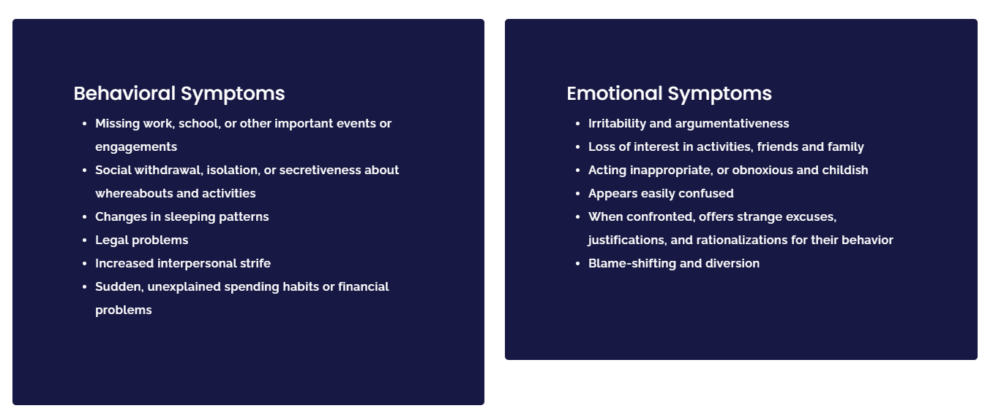

The main innovative device being presented observes the behavioral changes in a person and presents the analysis of the activity throughout a time. Many individuals in the current year have been posing a solution to interact and test the possibilities from a distance of their loved ones or an employee that they might have fallen into the temptations. Due to the methods that have been presented in history and the ability for tests to obtain positive results, all have been obtained through various contacts between one another. The tests used in modern-day time are testing through hair, urine, and other synthetics.

To limit the contact, the device presents a natural solution to everyday lives and inconsistency in behavior. Through extensive use of drugs in a person, the common behavior and emotional symptoms tend to differentiate over time, resulting in a much more frequent burst of spikes in the system. Whether the person experiences large inconsistencies in sleeping patterns, heart rate, priorities, the device will be able to analyze the person’s patterns to assess whether the results are positive or negative. Though it is not testing directly for the use of drugs, the system replaces the extensive use of modern testing of drugs and the limitations of interactions between individuals. Modern testing options are expensive and require many physical contact between many people for the duty to be accomplished.

The software being used in the device already has been proven to work in other inventions, it has been acquired for another form of use that provides an analysis of various graphs to create a pattern and distinctions to tell whether the person being tested should be analyzed through further tests. The ability to monitor blood behavior is very important throughout the testing process because when a person experiences drugs in their system; the blood tends to enhance the abnormal heart rates among the rest of the cardiovascular system [2]. A GPS device is also in use with the system that tracks everyday activity for the individual. Though common issues with the privacy rights of the person may be involved, the system does not record where the person’s whereabouts are, but the listed home of the person to engage in common assumptions whether the person is actively at. The typical use of drugs causes individuals to always have ongoing attitudes that will never be able to sit or stay in one place for long periods. Changes in priorities that have occurred from previous tests will analyze the behavior and compare the results of the person when they are or away from the listed home location provided. Finally, the device incorporates the use of government history in which it analyzes if the person has recently occurred any legal issues that need to be noted. Numerous studies have been acquired that state the common drug user has been convicted or have been encountered in a situation where legal authorities have been involved. Analyzing histories of encounters creates a large suspicion for the device in which further tests may be needed to conclude the results.

Modern-day testing has become very expensive throughout the years; [3] with urine tests averaging $30-60, and for hair and blood to over $200. This device will be able to limit the costs for the employer or the individual concerned. This device will also be able to limit physical interactions between people. Employers, in general, want to ensure their employees are the best they can obtain in the market. There are roughly 7.8 billion people in the world today which creates numerous difficulties for employers to assure they are receiving the best-qualified candidates for the positions they can. For those concerned for an individual, drug use has been known to destroy the home environment as well as personal relationships. With the budget being an issue in everyday lives, this device will limit the use needed to acquire conclusive drug tests that will give the results. Though it is another step in the process, through extensive use, the cost benefits will occur in the favor of the beholder.

Conclusion

To conclude, our device the “Glizzy Detector” is a new soon to be world-wide device that will shift the world completely. The innovation concocted by this group is bound to not only take over, but also offer a new outlook on the daily activities being performed. Our device serves two simple purposes in the end which are to track and record the behavioral changes of a person and give an analysis of the data over time. Such a product will not only be able to track illegal drug behavior, but even mental illnesses that could be weighing on a person without them even being aware of it. The avant-garde concept is not only beneficial to track all of these exceptional issues, but it is also convenient for the public as the people don’t need to do anything. In recapitulation, the purpose for the Glizzy Detector is to monitor any abnormal behavior that may correlate with abusing illegal substances(which are known to negatively impact your life in more ways than one) in hopes of getting the necessary help to relieve the issue.

References

[1] “How To Identify Drug Addiction Symptoms in Your Loved One,” *Mission Harbor Behavioral Health*. [Online]. Available: https://sbtreatment.com/addiction/symptoms/. [Accessed: 06-Nov-2020].

[2] National Institute on Drug Abuse, “Cardiovascular Effects,” *National Institute on Drug Abuse*, 15-Jun-2020. [Online]. Available: https://www.drugabuse.gov/drug-topics/health-consequences-drug-misuse/cardiovascular-effects. [Accessed: 06-Nov-2020].

[3] A. the A. N. Staff, “Drug Testing Explained: Cost, Devices, Privacy and Accuracy,” *Northpoint Recovery's Blog*, 25-Oct-2019. [Online]. Available: https://www.northpointrecovery.com/blog/drug-testing-explained-cost-devices-privacy-accuracy/. [Accessed: 06-Nov-2020].

[4]LaSusa, Mike. “5 Clever Ways Mexico Cartels Move Drugs Across US Border.” *InSight Crime*, 20 Sept. 2017, [www.insightcrime.org/news/analysis/5-clever-ways-mexico-cartels-move-drugs-over-us-border/.](http://www.insightcrime.org/news/analysis/5-clever-ways-mexico-cartels-move-drugs-over-us-border/.)

[5]National Institute on Drug Abuse, “Overdose Death Rates.” *National Institute on Drug Abuse*, 19 Oct. 2020, [www.drugabuse.gov/drug-topics/trends-statistics/overdose-death-rates.](http://www.drugabuse.gov/drug-topics/trends-statistics/overdose-death-rates.)

[6]“Suicide Statistics.” *American Foundation for Suicide Prevention*, American Foundation for Suicide Prevention, 28 Oct. 2020, afsp.org/suicide-statistics/.

[7]“Why Drug Testing in the Workplace Is Important.” *Ahwatukee Health and Recovery*, 9 July 2019, www.ahwatukeehealthcare.org/why-drug-testing-in-the-workplace-is-important/.